**WAGNER—**Letter F – 6/4 meter (*Clarinet in Bb)

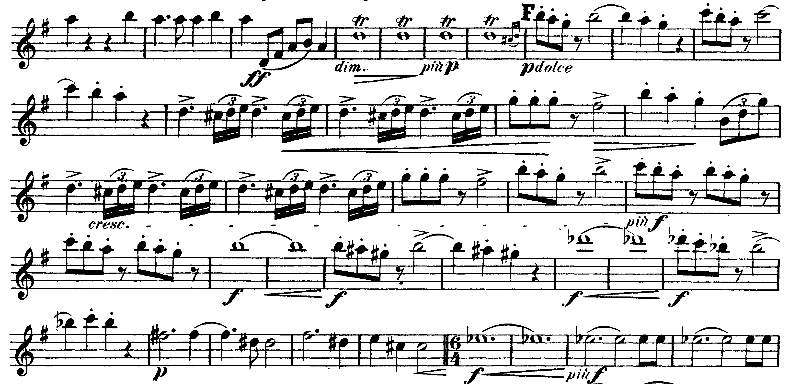

Letter L – Clarinet II cue (*Clarinet in C)

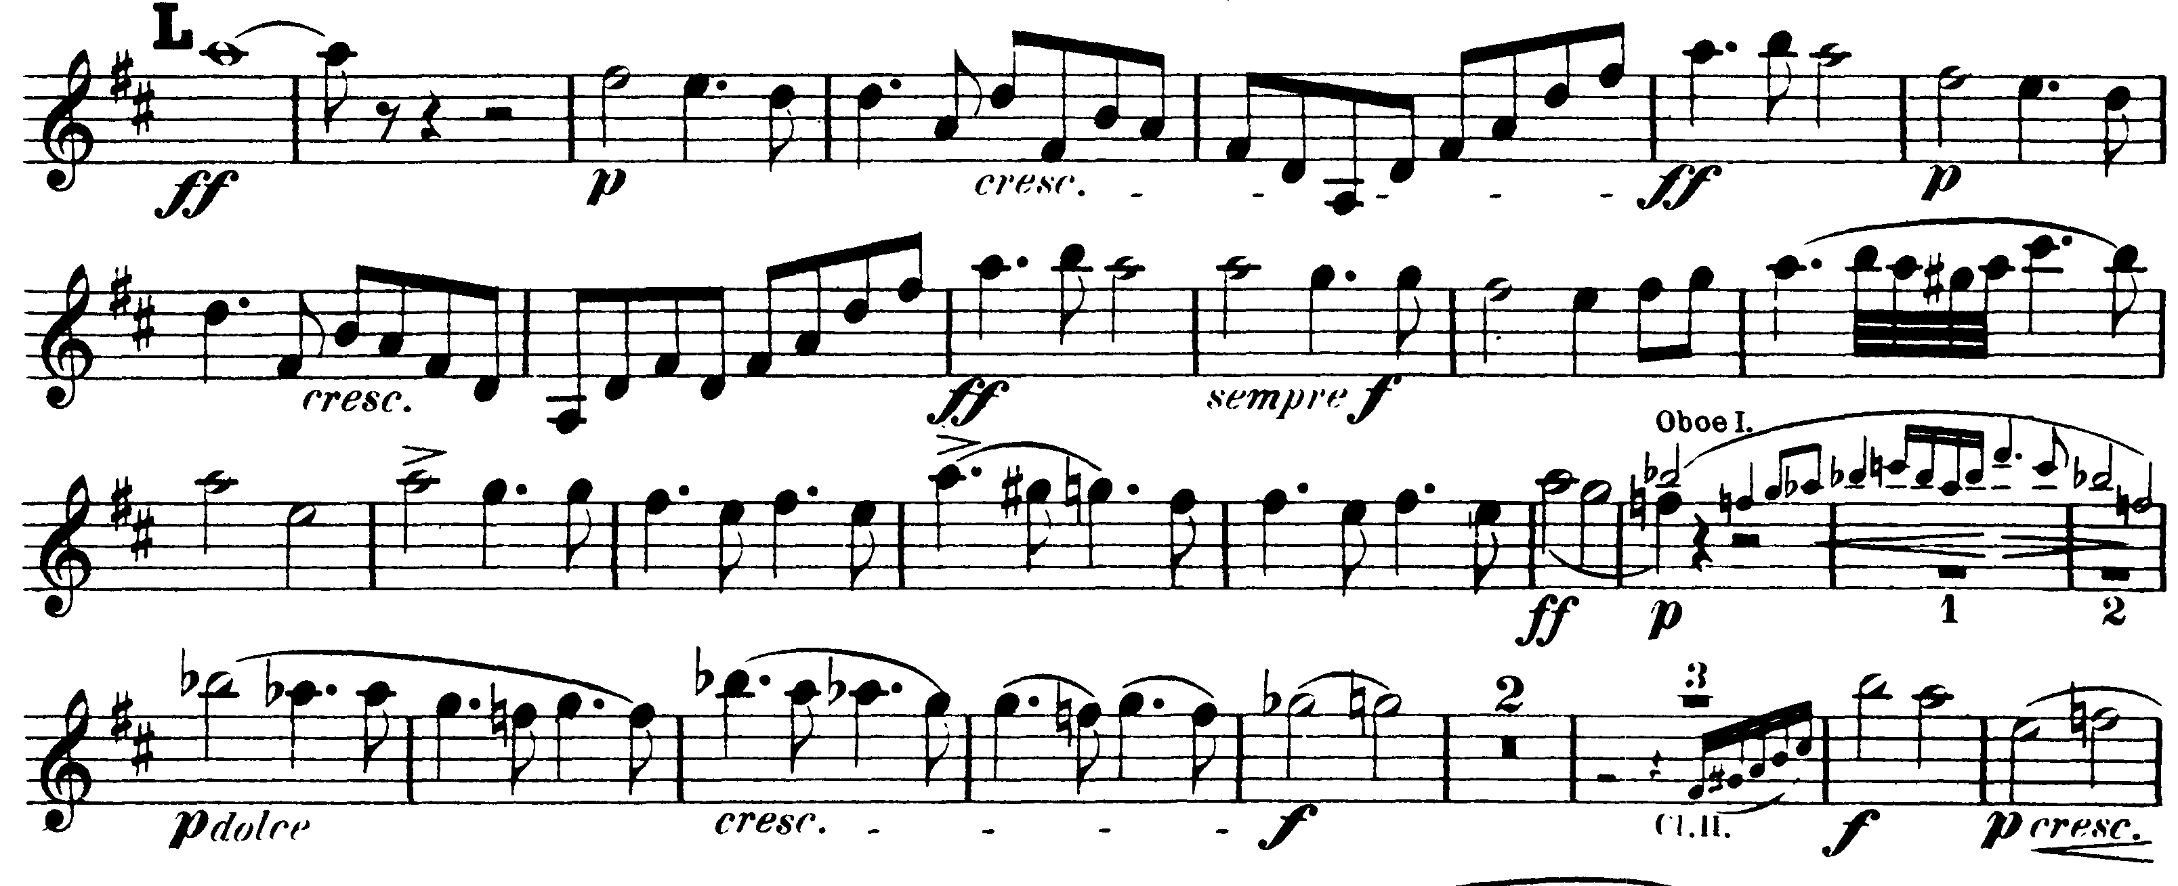

**TCHAIKOVSKY—**Mvt I: 1 – 38 (*Clarinet in A)

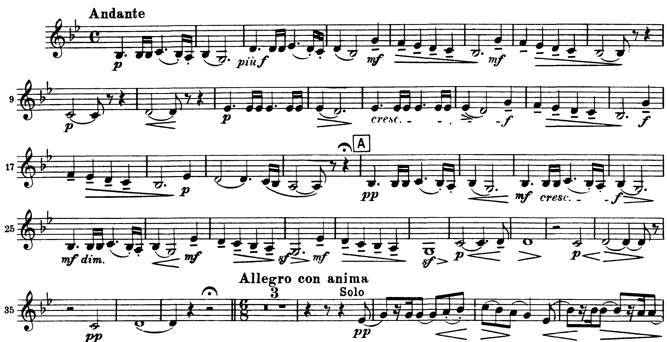

Mvt II: 67 (Moderato con anima) – 70 (*Clarinet in A)

